**ALGORITHM AND PROGRAMMING REPORT: PIZZA ORDERING PROGRAM WITH IF,ELIF,ELSE STATEMENTS**



**Supporting Lecturer** :

I Gde Agung Sri Sidhimantra, S.Kom., M.Kom.

**Group Name :**

|  |  |
| --- | --- |
| Faiz Maulana | (24091397103) |
| Michiana Defi Gunawan | (24091397102) |
| Aar Aldiagys Aril Firaya | (24091397082) |

**INFORMATICS MANAGEMENT STUDY PROGRAM**

**VOCATIONAL FACULTY**

**STATE UNIVERSITY OF SURABAYA**

**2024**

* 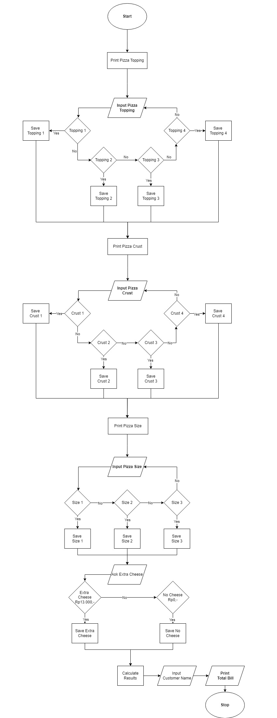**Flowchart :**
* **Flowchart Explanation :**

1. **(Terminator) Start**:

The program begins its execution.

1. **(Process) Print Pizza Topping**:

The program displays the available pizza toppings for the user to choose from.

1. **(Input/Output) Input Pizza Topping**:

The user is prompted to input their choice of pizza topping.

1. **(Decision) Decision: Topping = 1, 2, 3, or 4?**:
   * The program checks if the input corresponds to a valid topping option.
   * **Yes**: If the input is valid (1, 2, 3, or 4), the program assigns the price for the chosen topping.
   * **No**: If the input is invalid, the program prompts the user to input a valid topping number.
2. **(Process) Print Pizza Crust**:

The program displays the available pizza crust options.

1. **(Input/Output) Input Pizza Crust**:

The user is prompted to input their choice of pizza crust.

1. **(Decision) Decision: Crust = 1, 2, 3, or 4?**:
   * The program checks if the input corresponds to a valid crust option.
   * **Yes**: If the input is valid (1, 2, 3, or 4), the program assigns the price for the chosen crust.
   * **No**: If the input is invalid, the program prompts the user to input a valid crust number.
2. **(Process) Print Pizza Size**:

The program displays the available pizza size options.

1. **(Input/Output) Input Pizza Size**:

The user is prompted to input their choice of pizza size.

1. **(Decision) Decision: Size = 1, 2, or 3?**:
   * The program checks if the input corresponds to a valid size option.
   * **Yes**: If the input is valid (1, 2, or 3), the program assigns the price for the chosen size.
   * **No**: If the input is invalid, the program prompts the user to input a valid size number.
2. **(Process) Add Extra Cheese?**:

The program asks the user if they want to add extra cheese to their pizza.

1. **(Decision) Decision: Yes or No?**:
   * **Yes**: If the user answers "yes," the additional cost for cheese is added to the total price.
   * **No**: If the user answers "no," no extra cost is added.
2. **(Process) Calculate Total Price**:

The program calculates the total price by summing the prices of the selected topping, crust, size, and any additional cheese.

1. **(Input/Output) Print Customer Name**:

The program prompts the user to enter their name for the order.

1. **(Terminator) Stop**:

The program ends.

* **Summary of Flowchart Functions**

1. **Terminator (Start/Stop**): Represents the start and end points of the flowchart.
2. **Process**: Indicates a process or action that takes place.
3. **Input/Output**: This shape is used when the program either requests input from the user or displays output.
4. **Decision**: Control the flow based on user choices or conditions. It typically involves a yes/no or true/false question, determining the next step based on the user's response.

* 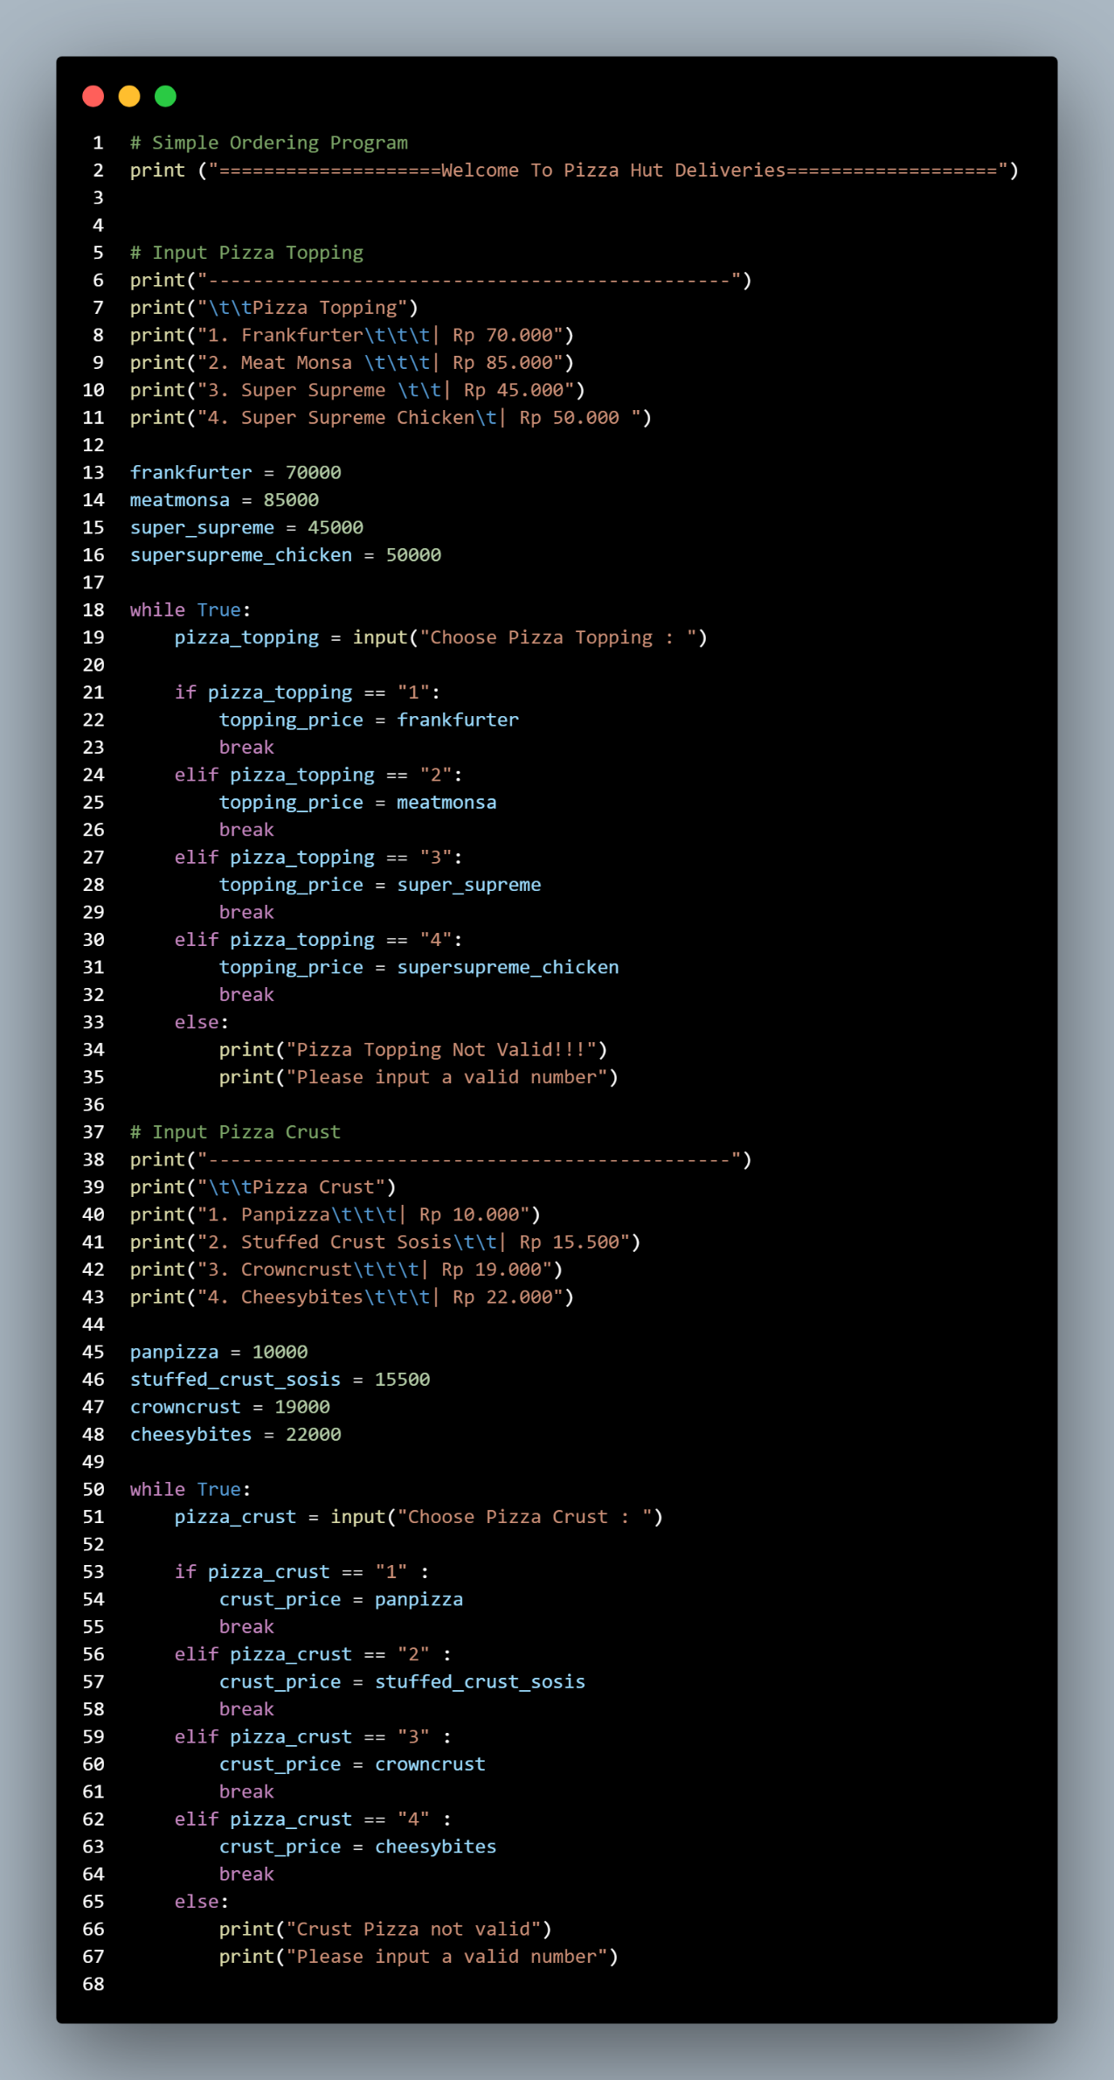**Source Code :**

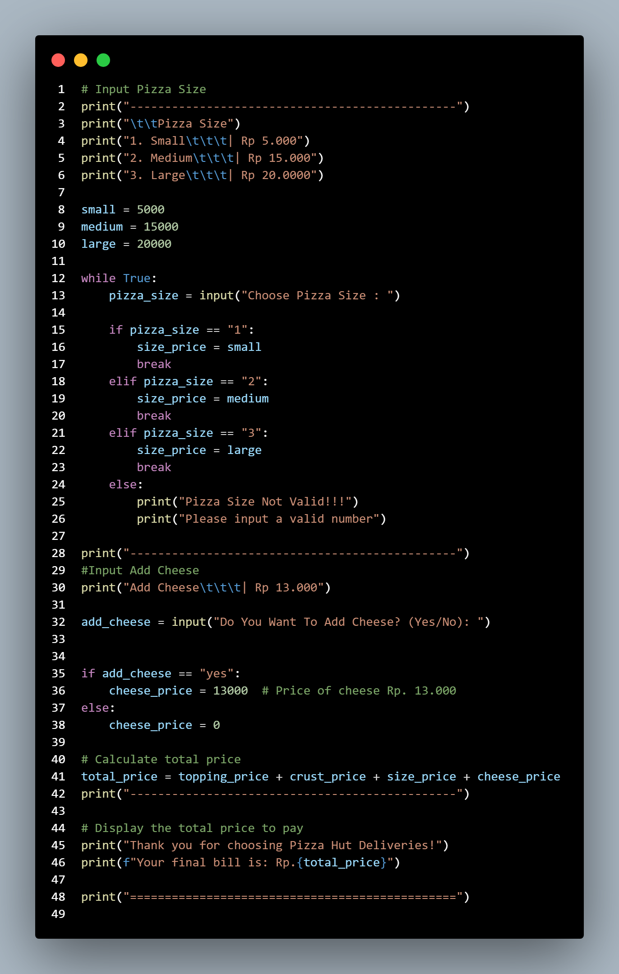

* **Explanation Of Each Command :**

**1.**



This line displays the text “Welcome To Pizza Hut Deliveries”.

**2.**

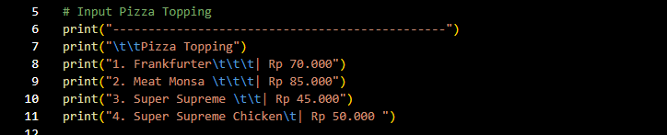

This code is used to display various types of Pizza Toppings along with their prices.

**3.**

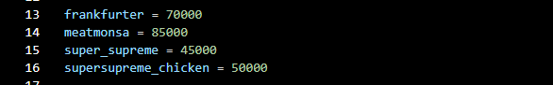

This line represents a variable that contains the price of each Pizza Topping.

**4.**



The while True code represents a loop that continues to run until break is executed within the loop, ensuring that the program continues to prompt the user for input until a valid choice is entered.

The input() function is used to request input from the user. This input will be stored in the variable pizza_topping. The message "Choose Pizza Topping:" will appear to inform the user to enter the number of the desired pizza topping.

**5.**

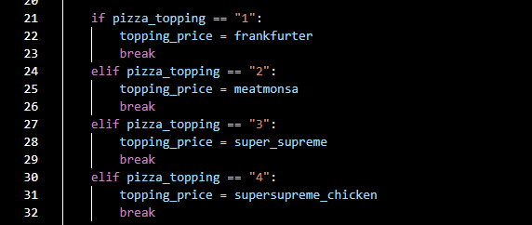

If the pizza_topping entered is "1", the price of Frankfurter (70000) will be set to the variable topping_price. break is used to exit the while loop, which means a valid input has been received and the loop does not need to run again.

If the input entered is "2", the price of Meat Monsa (85000) will be set to topping_price, and the loop will stop.

If the input entered is "3", the price of Super Supreme (45000) will be set to topping_price, and the loop will stop.

If the input entered is "4", the price of Super Supreme Chicken (50000) will be set to topping_price, and the loop will stop.

**6.**

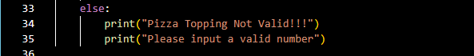

The else block is a substitute that will be executed if all previous conditions (if and elif) are False. This line indicates that if the input is invalid, the program will display the message "Pizza Topping Not Valid!!!" followed by "Please input a valid number" to prompt the user to enter a correct choice.

**7.**

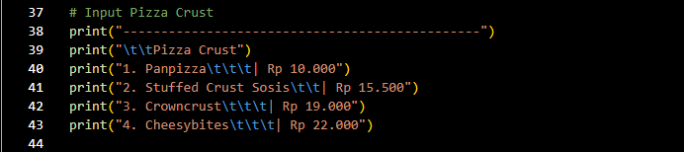

This code is used to display various types of Pizza Crusts along with their prices.

**8.**

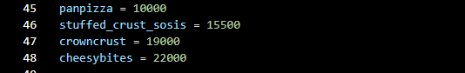

This line represents a variable that contains the price of each Pizza Crust.

**9.**



The while True code represents a loop that continues to run until break is executed within the loop, ensuring that the program continues to prompt the user for input until a valid choice is entered.

The input() function is used to request input from the user. This input will be stored in the variable pizza_crust. The message "Choose Pizza Crust:" will appear to inform the user to enter the number of the desired pizza crust.

**10.**

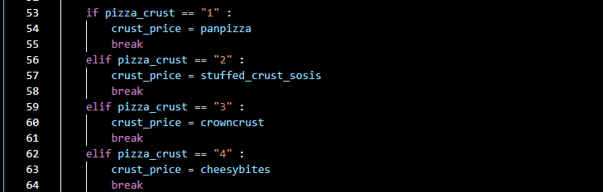

If the pizza_crust entered is "1", the price of Panpizza (10000) will be set to the variable crust_price. break is used to exit the while loop, which means a valid input has been received and the loop does not need to run again.

If the input entered is "2", the price of Stuffed Crust Sosis (15500) will be set to crust_price, and the loop will stop.

If the input entered is "3", the price of Crowncrust (19000) will be set to crust_price, and the loop will stop.

If the input entered is "4", the price of Super Cheese Bytes (22000) will be set to crust_price, and the loop will stop.

**11.**



The else block is a substitute that will be executed if all previous conditions (if and elif) are False. This line indicates that if the input is invalid, the program will display the message "Crust Pizza Not Valid!!!" followed by "Please input a valid number" to prompt the user to enter a correct choice.

**12.**

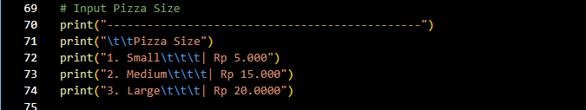

This line displays various size options for Pizza along with their prices.

**13.**

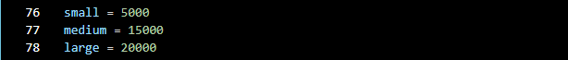

This line represents a variable that stores the price of each Pizza Size.

**14.**



The while True code represents a loop that continues to run until break is executed within the loop, ensuring that the program continues to prompt the user for input until a valid choice is entered.

The input() function is used to request input from the user. This input will be stored in the variable pizza_size. The message "Choose Pizza Size:" will appear to inform the user to enter the number of the desired pizza size.

**15.**

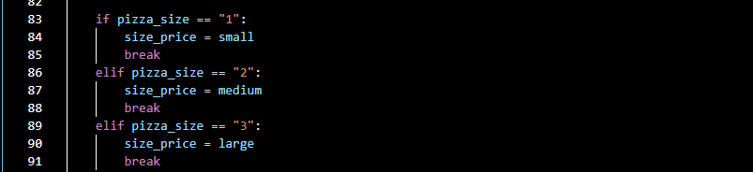

If the pizza_size entered is "1", the price of Small size (5000) will be set to the variable size_price. break is used to exit the while loop, which means a valid input has been received and the loop does not need to run again.

If the input entered is "2", the price of Medium size (15000) will be set to size_price, and the loop will stop.

If the input entered is "3", the price of Large size (20000) will be set to size_price, and the loop will stop.

**16.**



The else block serves as a substitute that will be executed if all previous conditions (if and elif) are False. This line indicates that if the input is invalid, the program will display the message "Pizza Size Not Valid!!!" followed by "Please input a valid number" to prompt the user to enter a correct choice.

**17.**

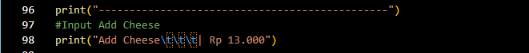

This line informs the user that they can add cheese for an additional cost of Rp 13.000,-

**18.**



The input() function is used to request input from the user. This input will be stored in the variable add_cheese, and will display the text asking “Do You Want to Add Cheese”.

**19.**

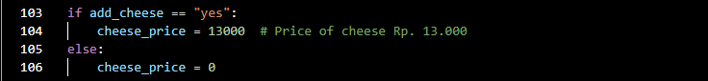

This line indicates that if the answer is "yes", the additional cheese cost will be set to Rp 13,000. If the answer is anything other than "yes", the cheese cost will be set to Rp 0.

**20.**



This code calculates the total price of the pizza order by summing the variables topping_price, crust_price, size_price, and cheese_price.

**21.**

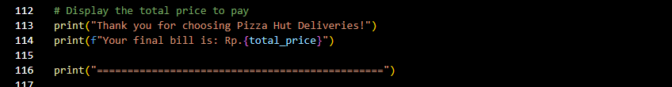

This line displays the message “Thank you for choosing Pizza Hut Deliveries,” and shows the total order cost from the sum of the variable total_price.

* **Output :**

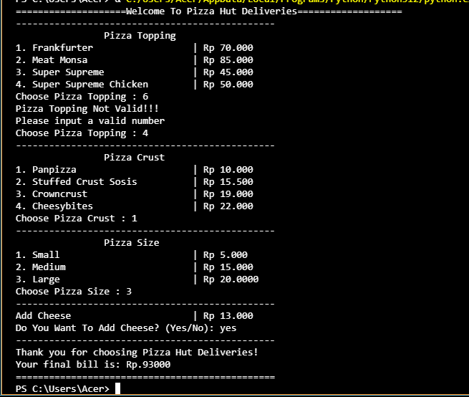

* **Conclusion**
* The pizza ordering program effectively utilizes if, elif, and else statements to manage user input and ensure valid selections for toppings, crusts, and sizes.
* If statements are employed to check specific conditions, allowing the program to assign prices based on the user's choices.
* Elif statements provide additional options, enabling the program to handle multiple valid inputs for each category of selection.
* The else statement serves as a fallback mechanism, ensuring that users receive feedback when their input does not match any valid options.
* Overall, the implementation of these control structures enhances the program's functionality, making it user-friendly and efficient for customizing pizza orders.